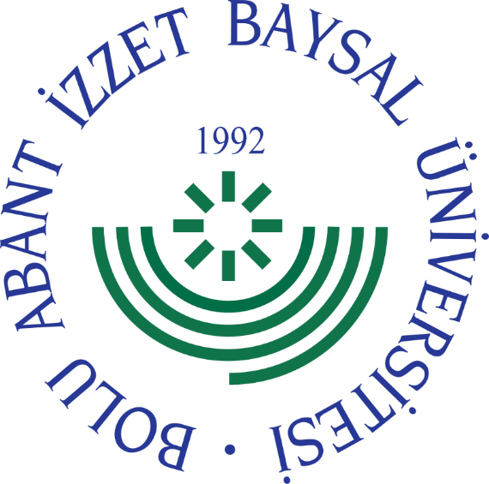

BOLU ABANT İZZET BAYSAL UNIVERSITY
SCHOOL OF FOREIGN LANGUAGES

FOREIGN LANGUAGES DEPARTMENT
PREP CLASSES
(ENGLISH AND ARABIC LANGUAGE)

BOOKLET FOR THE NEWLY REGISTERED STUDENTS
2023

The departments of the faculties/schools that offer ENGLISH PREPARATORY education in the School of Foreign Languages are as follows:*

COMPULSORY | OPTIONAL
Faculty of Education  - English Language Teaching  Faculty of Arts and Sciences  - Physics  - Chemistry  - Biology  - Mathematics  - Mathematics (English Medium)  - Psychology  Faculty of Economics and Administrative Sciences  - International Relations  - International Relations (English Medium)  Faculty of Engineering  - Chemical Engineering  School of Foreign Languages  - English Translation and Interpretation | Faculty of Education  - Computer and Instructional Technologies  Faculty of Tourism  - Tourism Guidance  Faculty of Economics and Administrative Sciences  - Economics  - Economics (English Medium)  - Business Administration  - Business Administration (English Medium)  - Public Administration  - Public Administration (English Medium)  - Finance  - Finance (English Medium)  Faculty of Communication  - Journalism  - Public Relations and Advertising  - Radio, Television, and Cinema  Faculty of Architecture  - Architecture  Faculty of Engineering  - Computer Engineering  - Environmental Engineering  - Electrical and Electronics Engineering  - Food Engineering  - Mechanical Engineering  Faculty of Health Sciences  - Nursing  - Physical Therapy and Rehabilitation  Faculty of Sports Sciences  - Coaching Education  - Coaching Education (English Medium)  - Physical Education and Sports Teaching  - Sports Management  - Sports Management (English Medium)  Faculty of Agriculture and Natural Sciences  - Horticulture  - Plant Protection  - Poultry Science  - Field Crops  - Seed Science and Technology  - Wildlife Ecology and Management  Gerede Vocational School of Applied Sciences  - Banking and Finance  - Marketing  - International Trade and Logistics
*This list is also applicable to international students.
If you have registered for a program with English Preparatory Education:

Before starting your undergraduate education, you must complete one academic year of English preparatory program in the English Preparatory Department. Students who wish to be exempt from the preparatory education must take the Academic Year Opening Foreign Language Proficiency Exam in English, which will be held on September 18, 2023. To be considered as "SUCCESSFUL" in this exam, you must score at least 60 points (80 points for English Language Teaching and English Translation and Interpretation Departments). Students who are successful in this exam will be eligible to start their courses in their respective departments.

Students who fail the English Language Proficiency Exam or do not take the exam are required to take the PLACEMENT TEST. Students who will receive preparatory education will be placed in level groups based on the results of this exam.
There are four (4) level groups in the English Preparatory Program:
Group A1: Beginner Level
Group A2: Basic/Lower Intermediate Level
Group B1: Intermediate Level
Group B1+: Advanced Level (For English Language Teaching and English Translation and Interpretation Department students admitted through Foreign Language Exam)

Students who wish to receive optional English preparatory education will also be placed in level groups based on the results of the Preparatory Class PLACEMENT TEST.
Students who will receive compulsory or optional preparatory education and do not wish to be exempt from the preparatory education do not need to take the Preparatory Class Language Proficiency Exam.
The above information is also valid for international students who have registered at our university.

For students receiving ARABIC preparatory education in the Preparatory Department, the faculties/schools offering compulsory Arabic preparatory education are as follows:

COMPULSORY
Faculty of Theology
- Theology
- Theology (English Medium)
- Theology (Arabic)

If you have registered or will register for a program with compulsory Arabic Preparatory Education:

Before starting your undergraduate education, you must complete one academic year of Arabic preparatory program in the Arabic Preparatory Department. Students who wish to be exempt from the preparatory education, must take the Academic Year Opening Foreign Language Proficiency Exam in Arabic, which will be held on September 19, 2023. To be considered as "SUCCESSFUL" in this exam, you must score at least 60 points (80 points for students in the Faculty of Theology, which offers 100% Arabic education). Students who are successful in this exam will be eligible to start their courses in their respective departments.
Those who do not pass the exam, will start their preparatory classes.
CONTACT INFORMATION FOR THE SCHOOL OF FOREIGN LANGUAGES PREPARATORY DEPARTMENT

Address: Bolu Abant Izzet Baysal University, School of Foreign Languages, Golkoy Campus, 14280 BOLU / TURKEY

Website: yabancidiller.ibu.edu.tr

Email: aibuhazirlik@ibu.edu.tr

Official Social Media Accounts:
Facebook (AIBU Hazirlik)
Instagram (@aibuhazirlik)
Twitter (@aibuhazirlik)

Fax: +90 374 253 5127

Phone: +90 374 254 10 00

